AN LAC SEAFOOD CO., LTD.
No. 38, 2A Street, Hung Vuong South – Tran Van Kieu North Residential Area, An Lac Ward, Binh Tan District, Hochiminh City, Vietnam.

No.: 04/ALC/ 2011
STATEMENT

TO.: SHING YUEH INTERNATIONAL CO., LTD.

DATE | INVOICE NO. | AWB | TOTAL
24 JAN | 010/ALC | 695 3379 9080 | 9,039.27
26 JAN | 011/ALC | 695 3394 6603 | 9,646.18
28 JAN | 012/ALC | 695 3394 6614 | 9,461.41
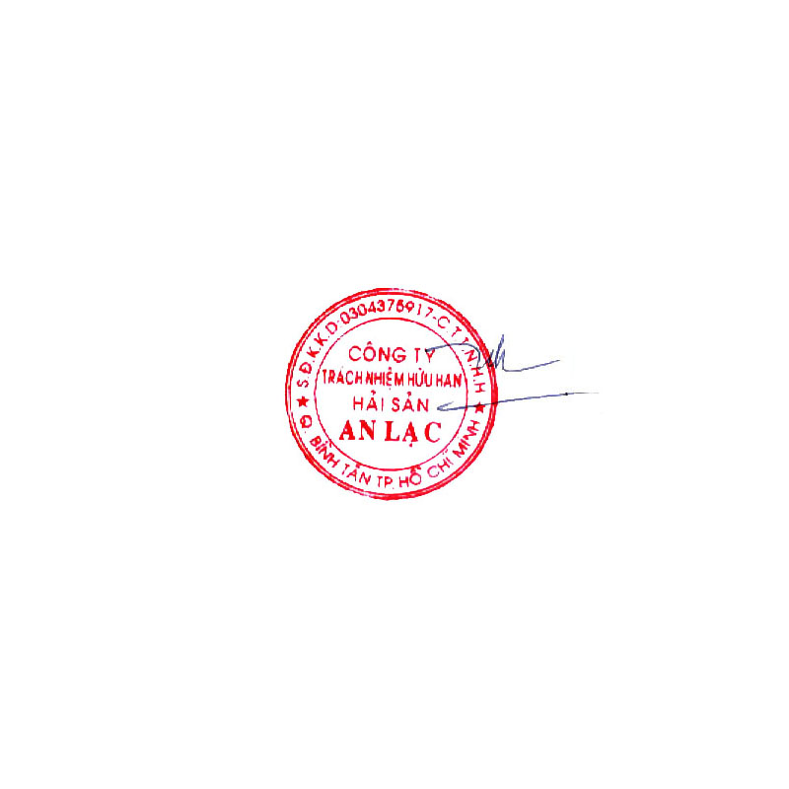  GRAND TOTAL |  |  | USD 28,146.86

Says: US DOLLARS Twenty Eight Thousand One Hundred Forty Six And Eighty-Six Cents Only.
AN LAC SEAFOOD CO., LTD.
Account No. : 1402 1485 100 3419
Name Of Bank : EXIMBANK, DISTRICT 4 BRANCH, HOCHIMINH CITY, VIETNAM.
SWIFT : EBVIVNVXQ04
AN LAC SEAFOOD CO., LTD.

Lê Thị Hoa

